Ivonne Santoyo-Orozco
Architectural Association School of Architecture

Ramírez Vázquez, Pedro (1919-2013)

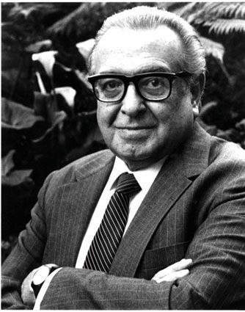
Pedro Ramírez Vázquez
http://www.inah.gob.mx/reportajes/6575-pedro-ramirez-el-arquitecto-que-construyo-para-la-gente

Pedro Ramírez Vázquez is arguably the father of Mexican modern architecture. He studied at the School of Architecture of the National Autonomous University of Mexico, and graduated by presenting the first thesis on urbanism in Mexico (1943). He had a prolific and influential career in his hometown, Mexico City, where some of his buildings have become landmarks of the capital, such as National Museum of Anthropology (1964), the Aztec Stadium (1966), the New Basilica of Our Lady of Guadalupe (1975), the Chamber of Deputies San Lazaro Legislative Palace (1980), among others. In addition to a prestigious architecture career, he also left a mark in other disciplines such as industrial design, graphic design, politics, and academia. Departing from architect, he created a series of sculptures and some pieces of furniture. He also contributed to the graphic design of the Olympic image of 1968. As a statesman, he served as the President of the Organising Committee of the Olympic Games of 1968. As a politician, he was given the office of the Secretary of Human Settlements and Public Works from 1976 to 1982 and other posts within the Secretary of Education. As an academic, he taught composition and urban planning at the National School of Architecture, and he was a founder and first Rector of the Metropolitan Autonomous University. Through all these endeavours, Ramírez Vázquez insisted that “design is not a work of art, it is a service”.

Since he was a student in secondary school, history had become a fascination for Rámirez Vázquez. And, it was through history that he would develop a passion for architecture. Particularly influenced by the teaching of the renowned poet Carlos Pellicer, his world history teacher, Rámirez Vázquez discovered a crucial relation between cohabitation and history that motivated him to become an architect. Through this relation, he cultivated an approach to design which aimed to display a nation looking towards the future, but without forgetting its past. His architecture could be described as responding to two historical sensibilities: european modernism and pre-columbian aesthetics.

His museology was particularly acclaimed. Besides the famous National Museum of Anthropology (1964), he designed many others, such as, the Museum of History Caracol (1960), the Museum of Modern Art in Mexico City (1964), and the Olympic Museum in Lausanne Switzerland. Rámirez Vázquez saw in the design of museums a didactic, aesthetic and social task that would link content and space into a single experience.

His work is as extensive as it is diverse, and Rámirez Vázquez’s most representative architectural contribution could be experienced in spaces for public gathering and educational buildings. Towards the beginning of his career, he developed a prefabricated modular design for rural schools (1958). With such a design, more than 30 thousand schools were built in just six years across Mexico. He also designed around 15 public markets among which are Mercado de la Lagunilla and Coyoacán in collaboration with Félix Candela and Rafael Mijares (1956). His work represented Mexico in several World Fairs including Brussels in 1958, Seattle in 1962, and Seville in 1992. His trajectory was honoured with a number of prizes, such as the Fine Arts Medal from the National Institute of Fine Arts (1973), and the Cemex Life Award in 2003, among many others.

Selected Works
1952. School of Medicine of the National Autonomous University of Mexico (In collaboration with Roberto Álvarez Espinosa, Ramón Torres Martínez and Héctor Velázquez), Mexico City.
1964. National Museum of Anthropology (In collaboration with Rafael Mijares and Jorge Campuzano), Mexico City.
1966. Aztec Stadium (In collaboration with Rafael Mijares and Luis Martínez del Campo), Mexico City.
1968. Graphic Design for the Olympic Games, Mexico 1968.
1975. New Basilica of Our Lady of Guadalupe (In collaboration with José Luis Benlluire, Alejandro Schoenhofer, Gabriel Chávez de la Mora and Javier García Lascuráin), Mexico City.
1980. Chamber of Deputies San Lazaro Legislative Palace (In collaboration with David Muñoz, Jorge Campuzano and Pedro Beguerisse), Mexico City.
1982. Tijuana Cultural Center (In collaboration with Manuel Rosen), Tijuana, Mexico.
1984. Torre Mexicana, Mexico City.

References and further reading:
Lazo Margain Alejandro, Rámirez Vázquez, Pedro eds. (1980) Industrial design and human development, Mexico City: Excerpta Medica, International Congress Series 510.
Rámirez Vázquez, Pedro. (1968) El Museo Nacional de Antropología. Arte, Arquitectura, Arqueología, Etnografía. Barcelona: Lausana.
Rámirez Vázquez, Pedro. (1988) Pedro Ramirez Vazquez: Imagen y Obra Escogida. Mexico City: UNAM. Colección México 93.

Visual material:
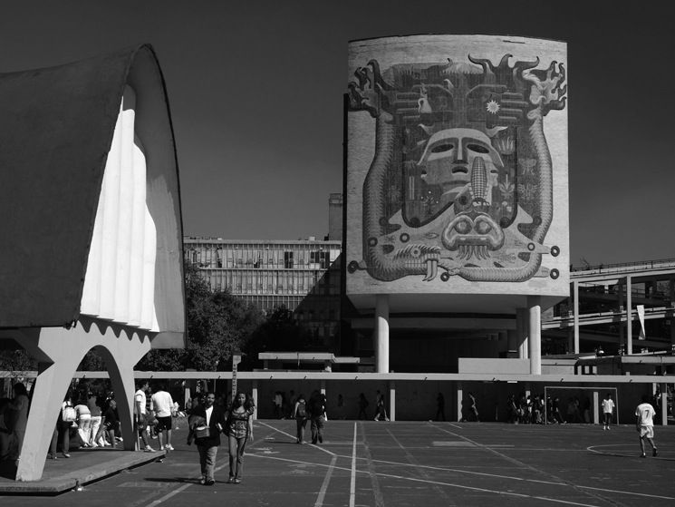
School of Medicine of the National Autonomous University of Mexico in Mexico City.
1952
http://www.arquine.com/blog/la-obra-de-ramirez-vazquez/

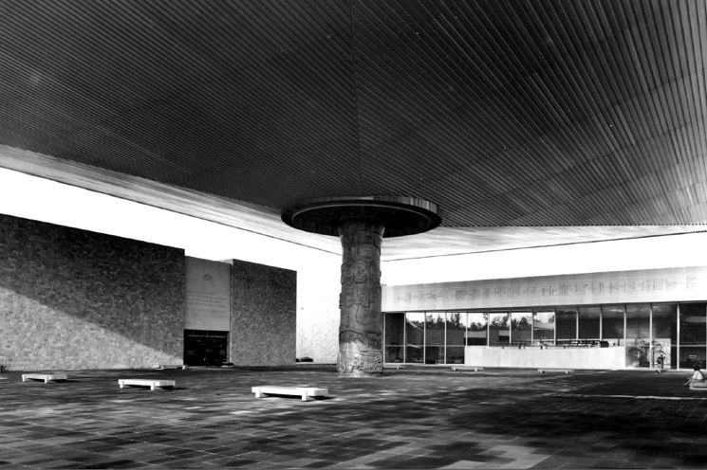

National Museum of Anthropology in Mexico City.
1964
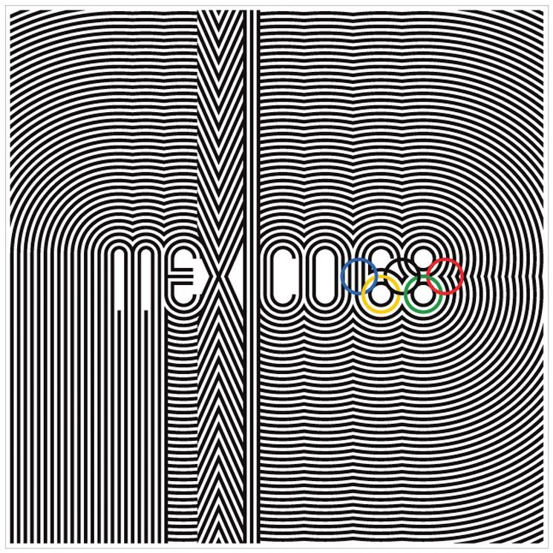
Graphic Design for the Olympic Games
1968
http://www.arquine.com/blog/la-obra-de-ramirez-vazquez/

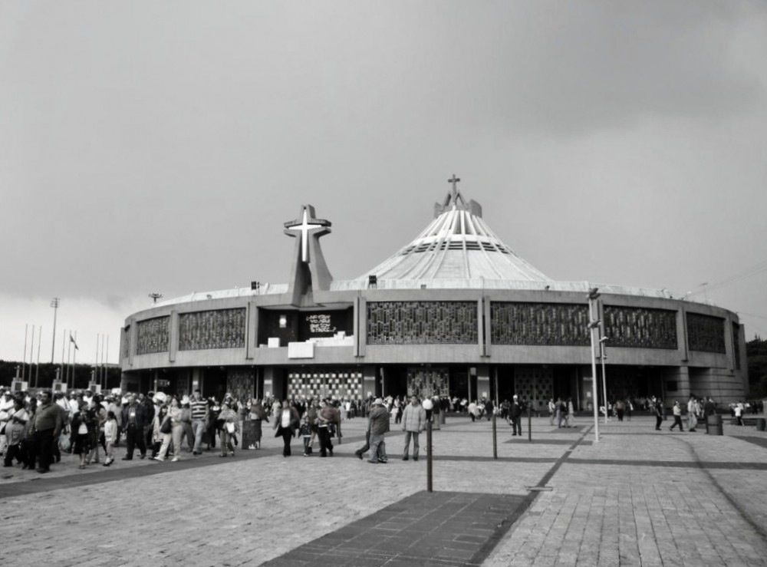
New Basilica of Our Lady of Guadalupe in Mexico City.
1975
http://www.archdaily.mx/215396/clasicos-de-arquitectura-basilica-de-santa-maria-de-guadalupe-pedro-ramirez-vazquez/

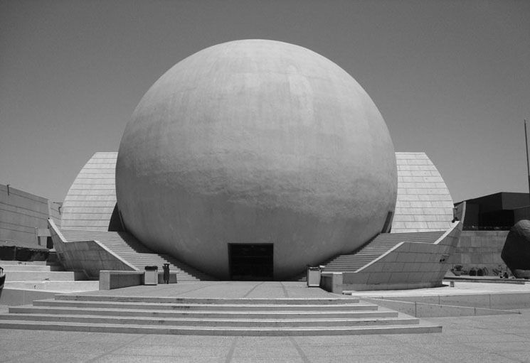
Tijuana Cultural Center in Tijuana, Mexico.
1982
http://www.arquine.com/blog/la-obra-de-ramirez-vazquez/

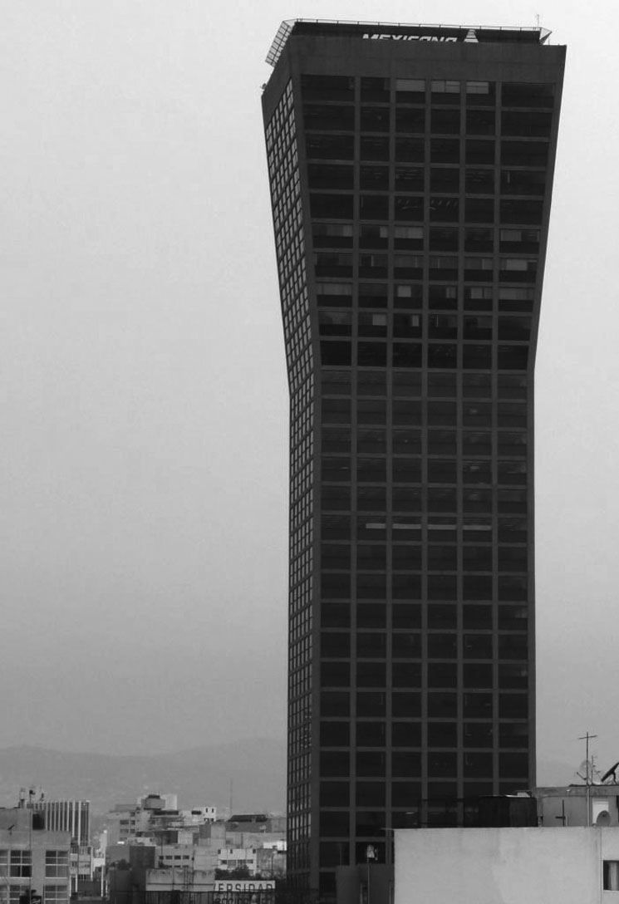
Torre Mexicana in Mexico City.
1984
http://www.arquine.com/blog/la-obra-de-ramirez-vazquez/

Lazo Margain Alejandro, Rámirez Vázquez, Pedro eds. (1980) Industrial design and human development, Mexico City: Excerpta Medica, International Congress Series 510. Page 36.

